TINKERING WITH TINKERCAD
A Beginner’s Guide to Creating 3D Model Designs
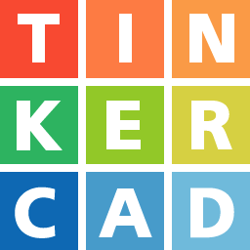

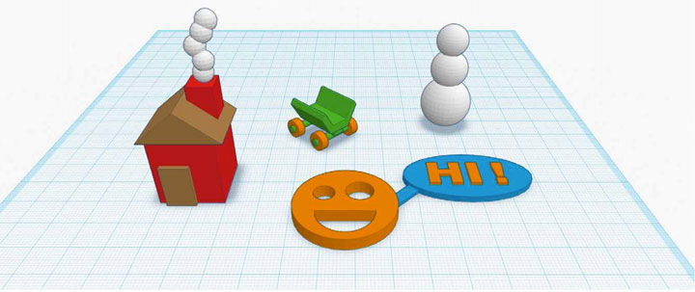
With Presenters:
Michael Hibben & Sarah Holmes
Tinkering With Tinkercad
Welcome!
In this workshop, you’ll get a brief introduction to the world of 3D model file creation using Tinkercad. We’ll learn what it is and how it works. We’ll also create a 3D model file in class and you’ll have the option of 3D printing it.
What is 3D Printing?
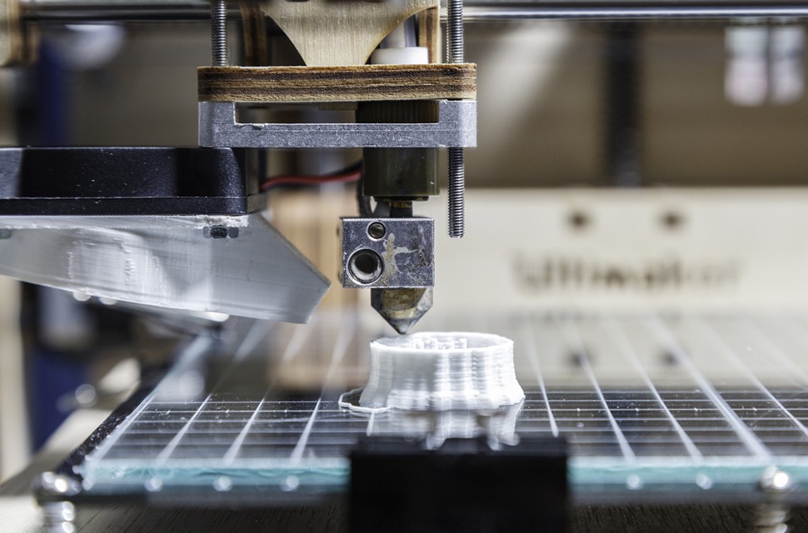

3D printing -- also known as additive manufacturing -- turns digital 3D models into solid objects by building them up in layers. The 3D printing process turns a whole object into thousands of tiny little slices, then makes it from the bottom-up, slice by slice. Those tiny layers stick together to form a solid object.

3D printing was first developed in the 1980s for manufacturing and in recent years has been used for a variety of purposes - such as creating the models for stop motion films. 3D printing works through a process called material extrusion: the nozzle of a 3D printer pushes out a semi-liquid substance into the shape the computer tells it to form, and repeats the process - building thin layers which form the object being printed.
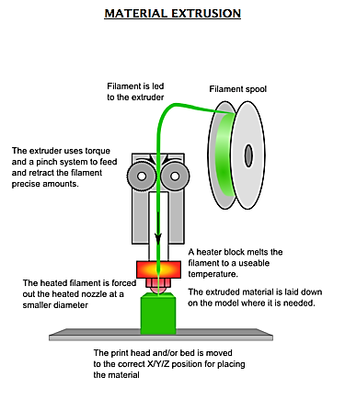

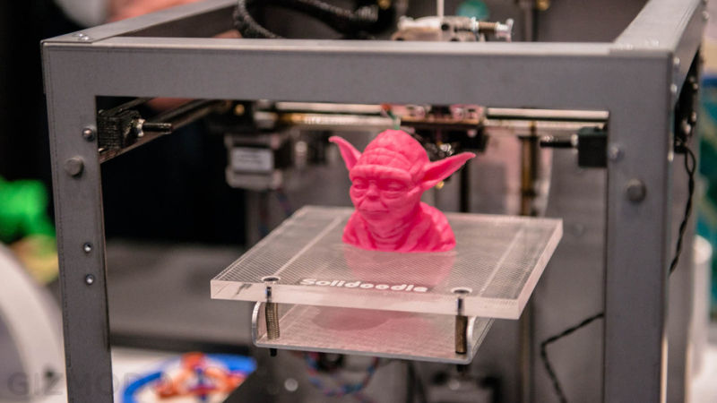

How do people create 3D model files?
Generally 3D model files are created with 3D model software. There are a lot of software options to choose from: some are web-based and some desktop based. This class is an introduction to Tinkercad, which is web-based software used to create and share 3D model files. What makes Tinkercad so great is how easy it is to use. If you can click and drag, then you can use Tinkercad!

Best browsers for Tinkercad
Some browsers work better with Tinkercad. When using Tinkercad, stick with these:
- Google Chrome 10 (or newer)
- Mozilla FireFox 4 (or newer)

Getting a Tinkercad account
- Open the Internet and type in: www.tinkercad.com
- Follow the steps to create your own account.
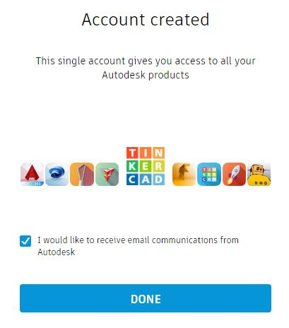
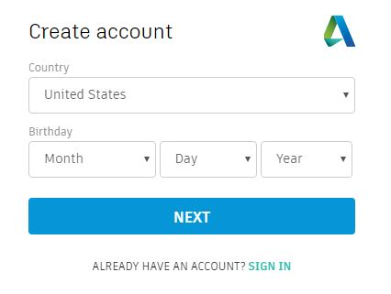
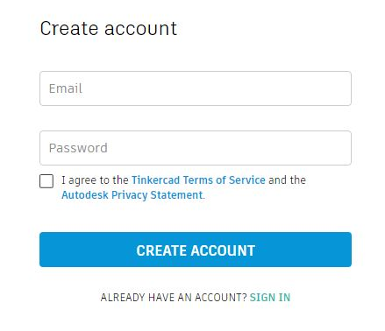

The Tinkercad workspace: An overview
When you open a new design in Tinkercad, you’ll notice many menus surrounding the screen. It might look a little overwhelming right now, but in this class we’ll go through each menu so you fully understand what function it serves and how it can help you create your new project.

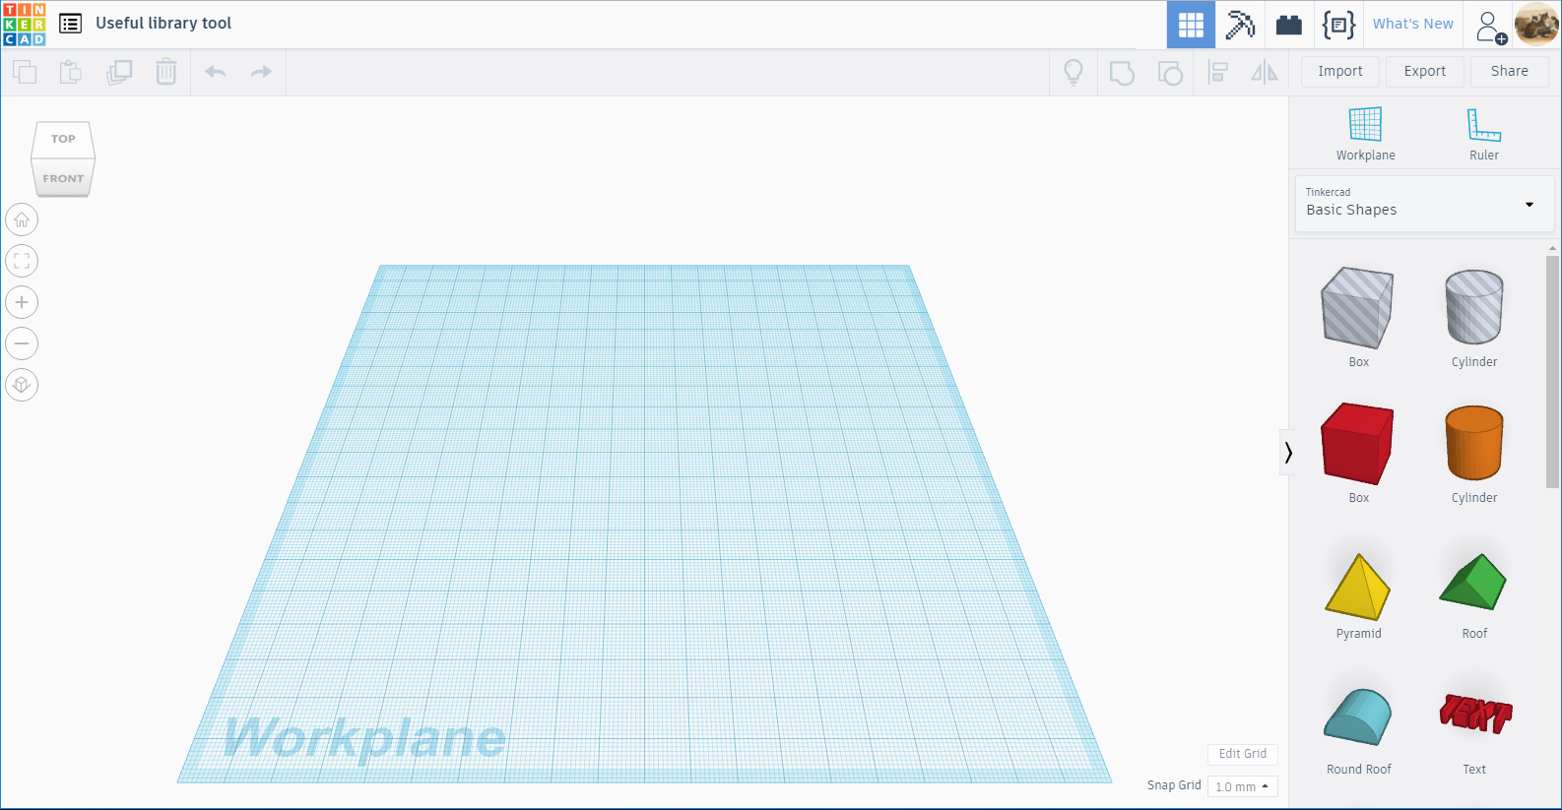
Project title
Workplane themes
zzzzzzzzzzz
Group/Alignment Menu
Import/Export/Share
Copy/Paste menu

Workplane options
Perspective menu

Your work space

Shapes & Symbols
Grid options

The Workplane
The most prominent thing you see when you click on the Create a new design button is the blue square that takes up most of the screen. This is the Workplane - the area you’ll click and drag shapes onto to create your new project. Think of it as a virtual tabletop on which you’ll create your new “thing.”

Workplane measurement: The metric system
The grid lines are all 1 mm apart, which makes it easy to see how large things are. The Snap Grid menu (on the lower left of the screen) is set to 1 mm by default, which means you can move things in 1 mm increments. But you can get more (or less) precise control over the movement of your things by clicking on the drop down menu to the right of the words Snap Grid. Simply choose a smaller (or larger) measurement to make your things’ movements more (or less) precise.

The Edit Grid Button
You can change other properties about your workplane by clicking on the Edit Grid button.

A menu will appear giving you options to change the following: Units, Presents, and Width & Height.

Units
If you hate the metric system, you can see your grid measurements in inches by selecting Inches from the drop down menu next to the word Units.

Presets
This dropdown menu changes the workplane size to match the build plate of certain brands of 3D printers.

Width & Height
You can manually adjust the width and height of your workplane by typing in a different measurement and then clicking the Update Grid button.

Some Basic Shape Menu How-Tos

- Moving a shape or symbol from the basic shapes menu to your Workplane (clicking and dragging)
  - Select which shape you would like to add to your Workplane.
  - Move your mouse over the Workplane where you would like to “drop” your shape.
  - Left click to “drop” shape and add it to the Workplane
*Note: Alternatively, you can left click and hold the shape you want, drag your mouse to where you want to put it on the Workplane and then let go of the left click button on the mouse to drop your shape

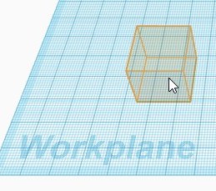
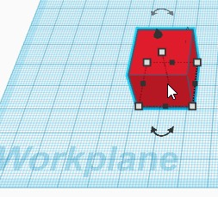
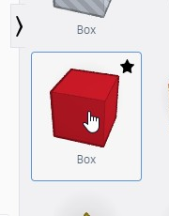
3.
2.
1.

- Resizing your shape.
  - There are many different ways to edit your shape once it’s on the Workplane.
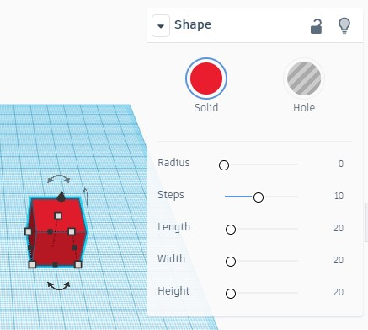
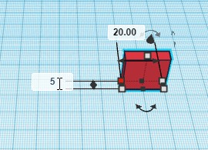
Click and drag the small white circles when you have a shape selected to make changes.

Once a shape is selected on the workplane, carefully click a small gray box to change a specific measurement of a shape by left clicking within the white text boxes that appear.
*Note: Selected points will change color from gray (unselected) to red (selected).

*Note: Alternatively, you can left click and drag any of the points to change the size/shape of the object selected.

- Moving a shape above or below the Workplane.
  - You can move a shape above the Workplane by clicking and dragging the cone-shaped handle above your shape. This function allows you to stack shapes on top of each other.
  - Remember to view your shape from the front to make sure it’s not floating above the Workplane. This could mess up your 3D print if the base of your project isn’t touching the Workplane.

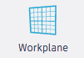
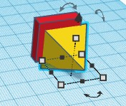
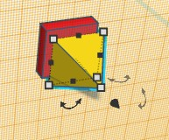
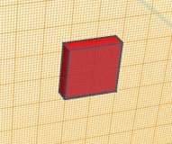
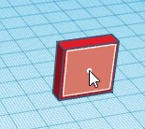
The Workplane button:
If you would like to work or build on the side of a shape, you can change the Workplane to be the surface of a shape side by clicking this button and then clicking the side of a shape.
4.
3.
2.

1.

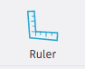
To use the ruler, click on the ruler button and then click where you would like the ruler to appear on the Workplane.
The Ruler button:

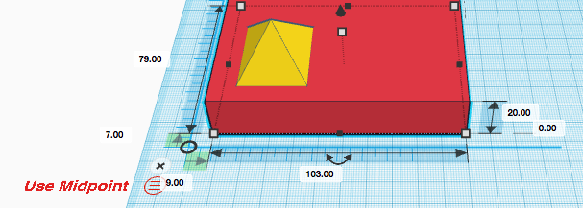
Once you have the ruler on the Workplane, you can select an object and then have the option to view the midpoint of the object selected or the endpoint.

Perspective Menu

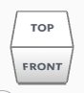
The perspective menu helps you change your view of the workplane. You can view your workspace from a variety of different angles by simply clicking one of these helpful menu buttons.
Perspective box – Click on a section of the box to change to that perspective of the Workplane.

Home button – Click this button to return to the default perspective of the Workplane.

Fit view to selection – Click this button to zoom specifically to the shape(s) you have selected.

Zoom in – Click this button to zoom closer to the Workplane. It defaults to zoom into the middle of the Workplane.

Zoom out – Click this button to get a higher, more distant view of your work and the Workplane.

Orthographic view – Use this button to switch to orthographic view—a 2D view as opposed to a 3D view.

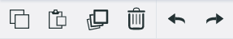
Copy/Paste Menu:

Use this menu to help you duplicate objects you create (saving you time), delete objects you no longer need, and undo and redo actions you take.
Copy – The first step in the “Copy/Paste” function. Click this button after you’ve selected a shape to copy it.

Paste – The second step in the “Copy/Paste” function. Use this button to paste something you’ve copied.

Duplicate – The copy/paste buttons in one step. Use this button to duplicate a selected shape or group of shapes on your Workplane.

Trash – Delete button. Use this button to get rid of a selected shape or shapes.

Undo – Go backwards a step.
Redo – Use this button to go forward a step or redo what was just undone.

Group/Alignment Menu:
Show All – Use this button to show or unhide all the shapes you’ve hidden. This button will be grayed out if there are no hidden shapes.
Group – Use this button to group selected shapes together so that you can move them or edit them as a unit.
Ungroup – Use this button to ungroup the shapes you’ve previously grouped together. This button will be grayed out if you have no grouped shapes.
Align – Clicking this button reviews a grid of black circles around your shapes. Click on a circle to align to or along that point of the grid.
Flip – Clicking this button after you’ve selected a shape or group of shape reveals two sided arrows which you can then click to flip your shape(s) in different ways.

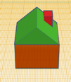
Goal: basic house
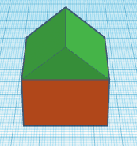
Your turn. Become a master builder.
Start with a basic house (if you want to be really fancy, add a chimney).

Step 1: Click and drag a “Box” shape from the Basic Shapes menu to your Workplane.
Step 2: Change the size of your box to be the size of house that you prefer.
Step 3: Change the area of your Workplane to the top of the box in order to add your roof.
Step 4: Add a “Roof” shape on top of your box shape to make a house.
Step 5: Change the color of your house.

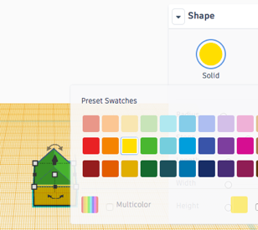
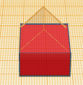
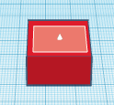
5.
4.
3.
2.
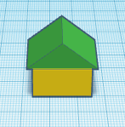
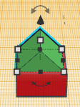
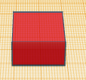
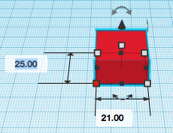
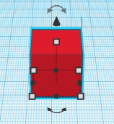
Congratulations! You did it!
1.
Creating your first project: A Keychain
The best way to learn a new skill, is by practicing. And to practice what you’ve already been shown, we’re going to create a personalized keychain.
- Click on the Create new design button

- Click and drag a box onto the Workplane.
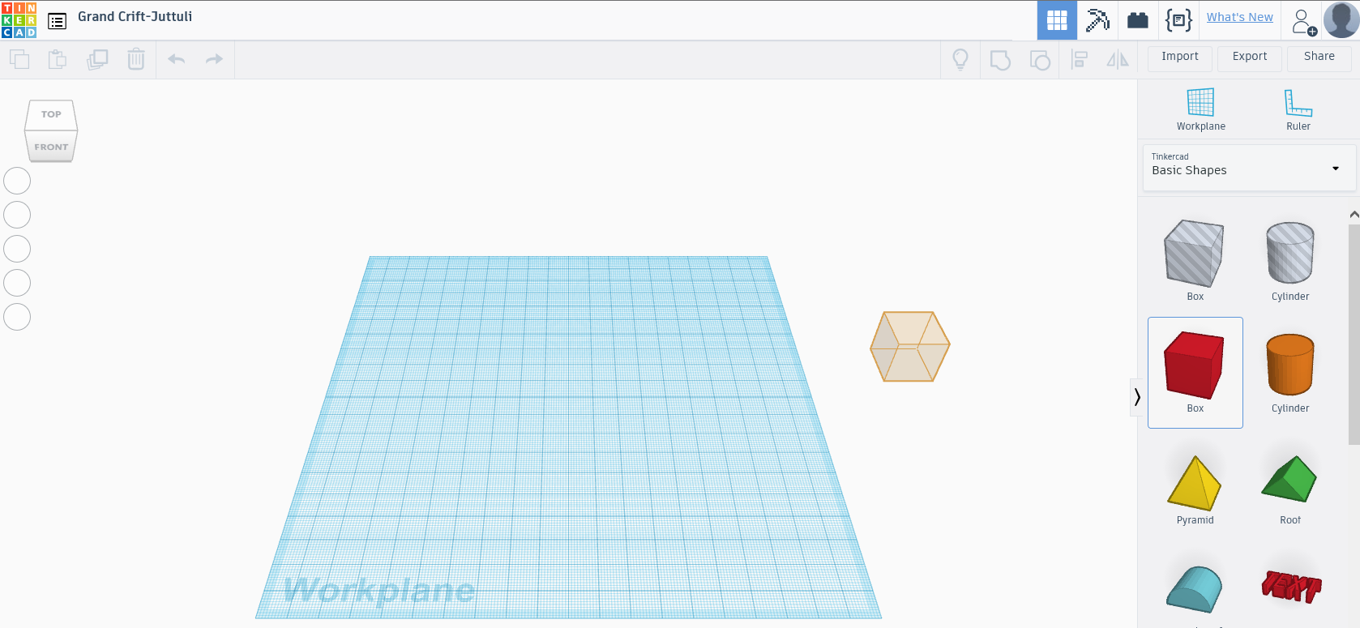

- Click and drag the box into a rectangle, roughly 77mm long by 22mm deep

- Grab the middle handle and reduce the height/thickness to around 3mm.

- Click and drag the Text shape onto the Workplane

- Type in your first name in the text box in the Shape menu appears. If your first name is long, you may need to click and drag the side of your box to make it longer.

- Once you’ve typed you name, drag it on top of your box.

- Click your middle handle and decrease the thickness of your name to around 6mm.

- Scroll to the bottom of your Basic Shapes menu and drag a tube onto the Workplane.

- Click and drag the middle handle to reduce the thickness of the tube to around 3mm.

- Drag your tube and place it so the bottom ¼ (or so) is inside your box.

- In the Shape menu, click on the Solid color dot, and then choose the color red from the color menu.

- Click and drag a square around your entire project.

- Click on the Group button, which will connect all the pieces of your project together.

- Admire your finished keychain!

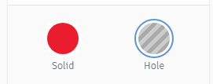
Creating holes with shapes
Every shape in Tinkercad has the option to be a “Solid” or to be a “Hole.”
The options are at the top of the Shape panel and affect whatever shapes are selected.

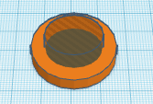
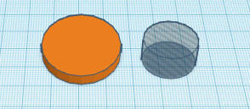
For example: If you wanted to create a ring, you could start with a solid cylinder and then add a smaller cylinder “hole” to the center making the cylinder into a ring shape.

Changing your project name
You’ll notice that Tinkercad automatically assigns any new project you create a name - usually something silly sounding. You can change you project name by clicking on the Tinkercad-assigned project name in the upper left corner of your screen:

Once you click on the name, it becomes a highlighted text box that you can then type over and rename your project whatever you’d like.

Saving your project
Saving a project you create in Tinkercad is easy because it’s automatically done for you. When you choose to exit your project, you’ll see a small green bar appear at the bottom of the screen that says Saving your work…Note, until you download your project, it’s saved in the cloud (aka, servers at Tinkercad).

The Import/Export/Share Menu
1.

Import
You’ll use the Import button to drag and drop a 2D or 3D file, or you can choose one that you’ve saved from your computer.
- You can download files you want to modify from 3D repository websites (like Thingiverse and MyMiniFactory) onto your computer and upload them into your Tinkercad account here.
- You can also upload pictures saved from online that you want to turn into 3D objects (we’ll cover this neat trick later)
Export
When you’re completely finished with your project, you’ll likely want to save it outside of Tinkercad, for later 3D printing. When you’re ready for this step, click on the Export button and follow these steps.

- Once you click the Export button, a Download menu appears giving you the option to save your object in either the .OBJ or .STL format. You’ll want to choose .STL (more on that in a minute).
1
1.

2
- If you click on the words 3D Print to the right of Download, a menu will appear allowing you to print everything on your workplane or just selected shapes. You can also automatically send your project to your MakerBot 3D printer or POLAR CLOUD brand 3D printers (if you own one).
2.

What Are .STL and .OBJ File Formats for 3D Printing?

.STL
.STL format is one of the most commonly used file formats for 3D printing. This is due to the fact that most CAD software has the feature of exporting models in .STL format and most 3D printers support it. Specifically, it is a file which "slices" a 3D model into a series of very thin 2D "layers." This output is then used to drive a stereolithography (or similar) machine which produces physical prototypes through layer-by-layer deposition the file generates the surface geometry of the modeled object only.

.OBJ
.OBJ format is considered to be more complex than .STL file for the fact that it is capable of representing texture, color and other CAD attributes of the three-dimensional object. .OBJ is also easily exported from most CAD tools and is supported by 3D printers.

Which to choose?
However, according to people’s opinion on forums and 3D printing enthusiast platforms, .STL seems to hold a top spot in the list of preference of file formats for 3D printing. The main reason is that this type of file is simpler to use and most mesh repair tools work better with STL files than .OBJ.
On the other hand, if you are willing to print a multi-color 3D model, you would want to choose .OBJ file format.

Share
The Share button allows you to share your design with others in a number of ways:
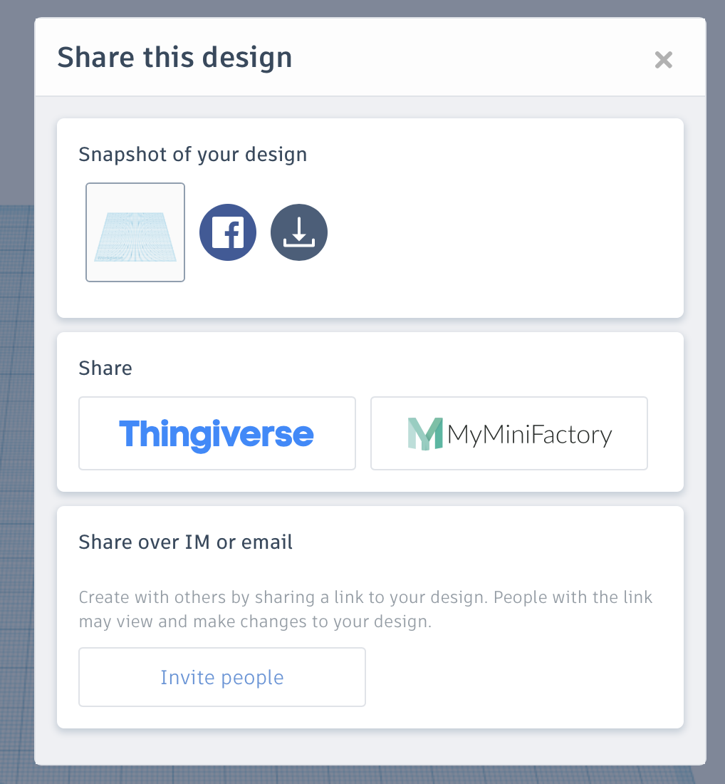
- Snapshot of your design
You can take a snapshot of your design and post it on
Facebook. You can also take a snapshot of your design and download it onto your computer.

- Share
If you’ve created an account with either Thingiverse or MyMiniFactory (both are popular 3D model repository websites, where you can upload your own 3D model files or download other creators’ files) these buttons will take you to a login window for those sites. Once you log in, you can automatically share your project on either (or both) sites.

- Share over IM or email
Clicking this button generates a link you can then send to other. People with this link may view and make changes to your design

Top menu overview
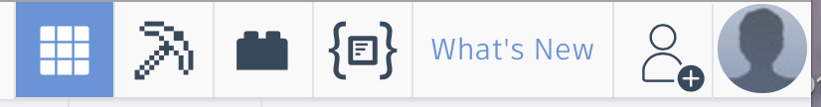

The menu at the top right hand corner of your screen features a number of different functions and options, some of which are more practical than others.

Design: This is the default screen which shows the standard workplane for your 3D designs.
Blocks: Allows you to design and view your work in “Minecraft” style.
Bricks: Allows you to design and view your work in “Lego” style.
Shape generators: With this function, you can create your own shapes using Javascript and save them to be used later by you or the Tinkercad community.
What’s New: Check out descriptions and modeling of the newest features in Tinkercad.
Collaborate: Click this button to share your work with others.
You: Your user profile. This button is a shortcut to your account page, to create a new design, to check out your designs, to view your notifications, change settings in your profile and log out.

Logging out/Logging back in with saved designs
- Click on the silhouette button on the top right corner of the screen. On the drop down menu that appears, click Log out.

- To log out of your Tinkercad account, click on the main Tinkercad button on the top left of your screen.

- Click on the silhouette button on the top right corner of the screen. On the drop down menu that appears, click Log out.

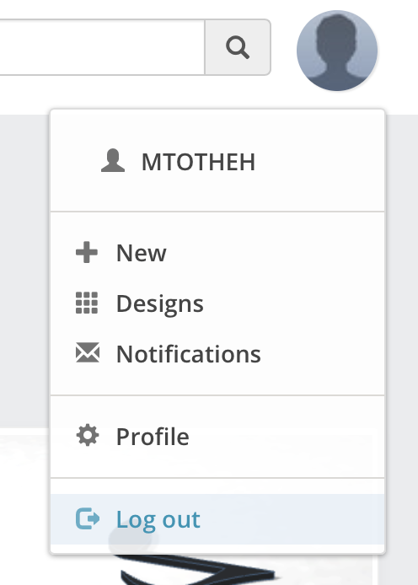

Website overview
Let’s take a look at the website overview menu that appears at the top left corner of the screen when you first log in to your account.
1.
2.
3.
4.
5.

- Tinkercad For…: Clickling this link make a little menu appear featuring trending projects on Tinkercad.
- Gallery: This link takes you to a gallery of project Tinkercad users have created and made public to share with the greater Tinkercad community.
- Community: Clicking this link brings up a pop-up menu where you can select from the following options: Blog, Help Center, What’s New?
- Learn: Clicking here takes you ta page full of Tinkercad tutorial and keyboard shortcuts.
- Teach: Teachers who wish to bring Tinkercad into their classes will find useful information here.

Limitations of Tinkercad and how to get around them
What is difficult to do in Tinkercad
- Drawings – You can’t free draw your project. You are limited to the shapes provided by Tinkercad.
- There are limited shapes to select from. Pre-loaded shapes can be limiting for complex parts.
- Due to its popularity in the education system, the website often slows down to a crawl during US school hours
- You will outgrow it very quickly.

Here are some tips and tricks to get around some of the limitations of Tinkercad.

Importing pictures
You can turn pictures into 3D files. Simply follow these steps:
- Find an image you want to try to turn into a 3D model and either save it to your computer or copy the web address.
- Go to a free file conversion website that will convert picture files (like those ending in .jpg) into SVG files (Scalable Vector Graphics – a vector image format for two-dimensional graphics with support for interactivity and animation). A website your instructors have used is https://convertio.co/jpg-svg/ .
- Upload the file (or paste the web address) into the conversion site.
- Download the newly converted file onto your computer.
- Log in to Tinkercad and import the file using the import button.
- Change or revise the file however you like. Note: This is a trial and error method of importing files into Tinkercad. Some picture files you convert into SVG files will look weird when imported into Tinkercad and make not be very usable.

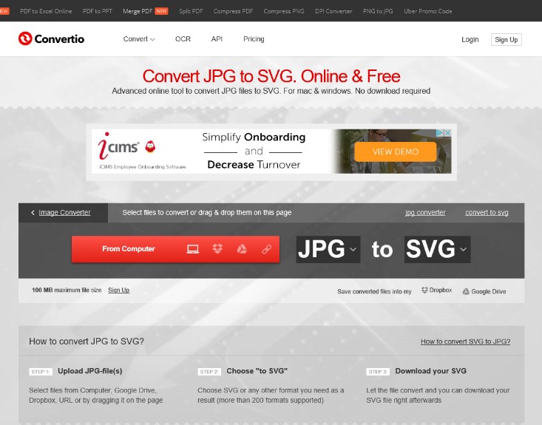

Building on other people’s designs
Did you know you can use Tinkercad to modify previously designed objects? Simply visit a 3D model file repository (like Thingiverse or MyMiniFactory) and download an item from the site that you want to edit or add onto. Then, import it into Tinkercad using the Import button.

Thingiverse (www.thingiverse.com)
Thingiverse is one of the biggest and most popular databases. It has a very active maker community behind it and offers free-to-use STL files only. You don’t even need to open an account in order to download a 3D model from their site.
MyMiniFactory (www.myminfactory.com)
MyMiniFactory, which launched in 2013, is the world's leading curated social platform for 3D printable objects. On MyMiniFactory, you can find tens of thousands of 3D designs ready for you to download for free.

Other 3D printing modeling software/websites
Once you’ve learned Tinkercad, here are a few other free sites that could help you take your 3D modeling skills to a more advanced level.

SketchUp (www.sketchup.com)
SketchUp is fun and free, and is known for being easy to use. To build models in SketchUp, you draw edges and faces using a few simple tools that you can learn in a short time. With a Push/Pull tool you can extrude any flat surface into a 3D form.
Blender (www.blender.org)
Blender is a professional, free and open-source 3D computer graphics software toolset used for creating animated films, visual effects, art, 3D printed models, interactive 3D applications and video games. Blender's features include 3D modeling, UV unwrapping, texturing, raster graphics editing, rigging and skinning, fluid and smoke simulation, particle simulation, soft body simulation, sculpting, animating, match moving, camera tracking, rendering, video editing and compositing. It further features an integrated game engine.
Useful resources
Here are some great additional Tinkercad tutorials that you can use in better learning Tinkercad:
http://www.instructables.com/id/Tinkercad-Tutorial/
https://www.thingiverse.com/jumpstart/tinkercad
http://spolearninglab.com/curriculum/lessonPlans/hacking/resources/software/3d/tinkercad_intro.html

YouTube is also a great Tinkercad tutorial resource!

Thank you for attending out Tinkercad class!
If you have more questions or need more help learning Tinkercad, please contact us.

Michael Hibben
Branch Manager
South County Library
Email: mhibben@roanokecountyva.gov:
PH: 540-777-8778

Sarah Holmes
Assistant Cataloger/Reference Librarian
South County Library
Email: sholmes@roanokecountyva.gov
PH: 540-772-7507

